Computational Physics_Dr. Ejtehadi
Project: Schelling Model of Segregation
Mahsa Rahimi_99100671
Introduction:
Schelling model of segregation is a classic agent-based model in computational social science. It was introduced by Thomas Schelling in the 1970s to illustrate how individual preferences, even mild ones, can lead to large-scale patterns of segregation.

Task 1 (GIF):
Build the Schelling model on an $N×N$grid with $N=60$, implement the movement step by step, show changes visually at each Step, and save them as a gif
We build the grid, initialise the agents with a given population density $ρ$ and random positions. We define agent groups: $M_{1}=1, M_{2}=2$ and use a tolerance threshold $B_{m}$with different values (e.g., 0.3). We then define neighbourhood check and happiness condition. Move unhappy agents one step per frame (all at once) and then create a GIF from the images using imegeio.


Task 2:
Sweeping over different $B_{m}$ values (threshold tolerance) and plotting the average number of moves needed for the system to reach equilibrium. $B_{m}$ spans 0.1 to 0.6 and uses 5 runs per $B_{m}$.
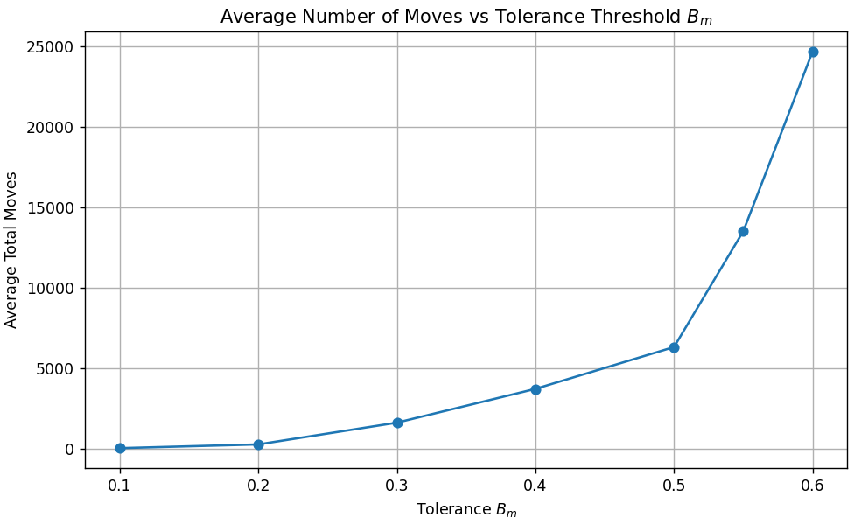
Task 3:
We want to see how population density $ρ$ affects the number of moves needed for equilibrium. We fix $B_{m}$ at the value 0.4 and vary $ρ$ from 0.6 to 0.95 (running 5 times per $ρ$.
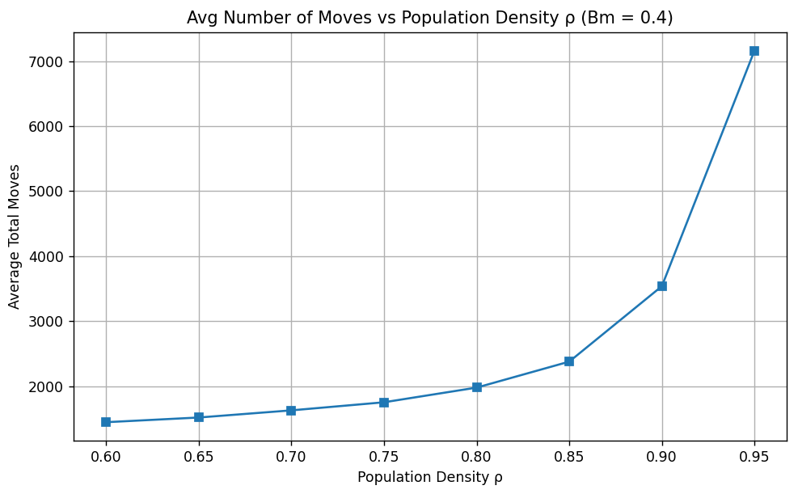
Task 4:
The Schelling model is based on individual preferences, if an agent wants to live near enough neighbours of the same type, and if not, they move. If the individual threshold is low, the overall effect of everyone acting on this rule leads to clustering over time.
Here, after agents finish moving, we go cell by cell, check each agent’s neighbourhood and compute how satisfied each is. By averages all these values we get $⟨s⟩$. This is our measure of global segregation.
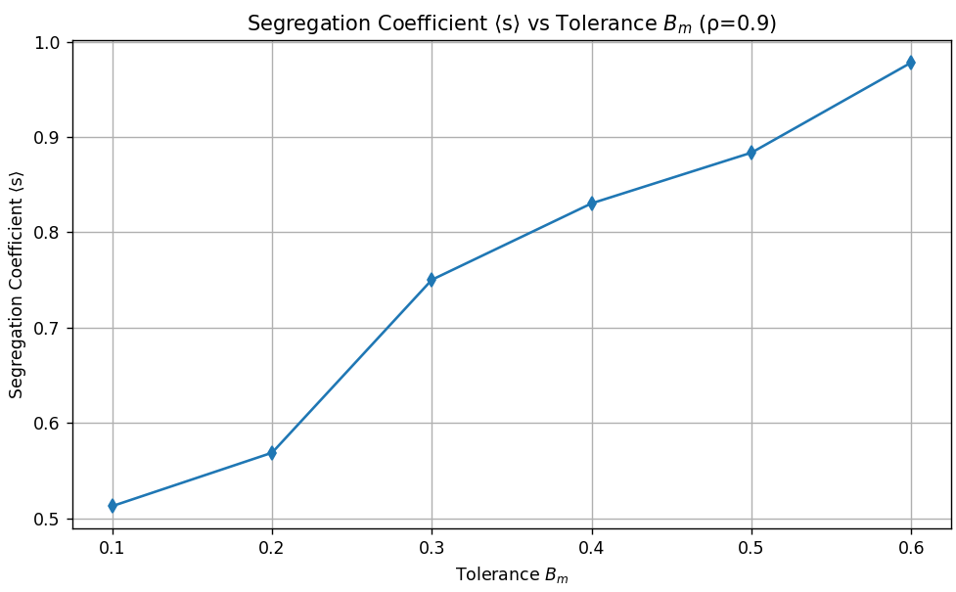
Task 5:
We fix $B_{m}$ at 0.4 and sweep over 8 different $ρ$ values from 0.6 to 0.95 (5 runs for each value) and we compute and average the segregation coefficient $⟨s⟩$. Then plot $⟨s⟩$ vs $ρ$.
